Orbis Terrarum

Analyse document

Contents

Version History 3

Requirement 4

Use Cases 5

Diagrams 6

User interface 6

Context Diagram 6

Conceptual Diagram 6

Class Diagram 6

UI Design 7

Test Cases 8

# Version History

|  |  |  |
| --- | --- | --- |
| **Version number:** | **Date:** | **Description:** |
| 1 | 01-03-2023 | Created Requirements |
| 2 | 20-04-2023 | Document was corrupted, this is salvage |
|  |  |  |

|  |  |  |  |  |
| --- | --- | --- | --- | --- |
| Requirement | **Must** | **Should** | **Could** | **Won’t** |
| The code is written in English and meets coding standards |  |  |  |  |
| The application is made in C# and uses the ASP.net framework together with MVC |  |  |  |  |
| There is a database where all needed data is stored |  |  |  |  |
| There is a login page for users |  |  |  |  |
| Creators can invite viewers with a code/link |  |  |  |  |
| Visitors can make suggestions to the Creators |  |  |  |  |
| Creators can make a world |  |  |  |  |
| Creators can manage events |  |  |  |  |
| Creators can create and manage important characters |  |  |  |  |
| Creators can create a timeline for their world |  |  |  |  |
| Creators can load in an image to represent their map |  |  |  |  |
| Visitors can create things based on privileges given by Creator |  |  |  |  |
| Users can register as a Creator on the login page |  |  |  |  |
| Creators have an overview page where they can see basic information |  |  |  |  |
| Connected events are displayed together with the thing they are connected to (multiple Models on a view) |  |  |  |  |

|  |  |  |  |  |
| --- | --- | --- | --- | --- |
| Requirement - Functional | **Must** | **Should** | **Could** | **Won’t** |
| RQ-01: There is a login page for users.  Quality: failed logins are properly caught and handled.  Limitation: User cannot go to other pages when not logged in. |  |  |  |  |
| RQ-02: Creators can make a world.  Quality: A clean overview is used for showing what needs to be filled in.  Limitation: You need to be a creator to create a world. You can only have one world at a time. |  |  |  |  |
| RQ-03: Users can register as a Creator on the login page.  Quality: The Button is in place of the create world button.  Limitation: Only people who aren’t a creator can see this button. |  |  |  |  |
| RQ-04: Creators have an overview page where they can see basic information.  Quality: The dashboard of a world contains the basic information of that world.  Limitation: Only the things that are filled in the database will be shown on screen. |  |  |  |  |
| RQ-05: Connected events are displayed together with the thing they are connected to (multiple Models on a view).  Quality: Events contain each character connected to the event; you can navigate to these characters.  Limitation: Any connected info needs to be represented in the database for secure connecting. |  |  |  |  |
| RQ-06: Creators can manage events.  Quality: as a creator you can make, edit, delete, and view all events connected to your world.  Limitation: Events of other creator’s worlds cannot be edited. |  |  |  |  |
| RQ-07: Creators can create and manage important characters.  Quality: As a creator you have the standard crud capability over your characters.  Limitation: You cannot affect other people’s characters. |  |  |  |  |
| RQ-08: Creators can invite viewers with a code.  Quality: On the overview page of the world is a button that can be used to create the link.  Limitation: A link is only good for 3 days before it expires. |  |  |  |  |
| RQ-09: Creators can create a timeline for their world.  Quality: Connected events are showed on the timeline.  Limitation: Only things that are connected to the timeline are displayed. |  |  |  |  |
| RQ-10: Creators can load in an image to represent their map.  Quality: These files are stored locally and have their path stored in the database for finding them.  Limitation: Only file types of the .jpeg format are accepted. |  |  |  |  |

# Use Cases

| Name: | UC-01: Login page (RQ-01) |
| --- | --- |
| Summary | The user fills in their e-mail and password to gain access to the website. |
| Actors | Creator, Guest |
| Requirements | The user is on the login page. |
| Scenario | 1. User fills in login information. 2. User clicks login button. 3. Software checks if login information is properly filled in. 4. Software gives okay for logging user in. 5. User is logged in and redirected to dashboard |
| Exception | * The user fills in incorrect or no login information. A warning is shown that incorrect information is filled in. The user is not redirected. |
| Result | The user is successfully logged in and redirected to the dashboard. |
| Priority | 1 |

| Name: | UC-02: Create World (RQ-03) |
| --- | --- |
| Summary | The user creates a World that they wish to develop |
| Actors | Creator |
| Requirements | The user is logged in as a Creator. The user is on the dashboard |
| Scenario | 1. User clicks the “Create World” button. 2. Software directs user to world creation page. 3. User fills in the required information. 4. User clicks the “Finalize” button. 5. Software checks if all information is properly filled in. 6. Software saves world in database. 7. The user is redirected to the basic overview of their world. |
| Exception | * The user does not fill in every field or enters wrong information. A prompt is shown to either correct or fill in any missing fields. * The user is at the maximum number of worlds they can create. A prompt is shown that they will need to remove a world to create a new one. |
| Result | The user successfully creates a world and is directed to the overview page of it. |
| Priority | 1 |

| Name: | UC-03: View World (RQ-02) |
| --- | --- |
| Summary | The user navigates to the world that they wish to view |
| Actors | Creator |
| Requirements | The user is logged in as a Creator. The user is on the standard overview page |
| Scenario | 1. User clicks on the world they wish to view. 2. Software loads in information of selected world and puts it in view. 3. User is redirected to the view page of that world. |
| Exception | * The user does not have any worlds to view. They will first have to create a world to be able to see it. |
| Result | The user successfully navigates to the overview of that specific world. |
| Priority | 1 |

| Name: | UC-04: Update World (RQ-02) |
| --- | --- |
| Summary | The user updates a World that they wish to develop |
| Actors | Creator |
| Requirements | The user is logged in as a Creator. The user is on the overview of the world they wish to edit |
| Scenario | 1. User clicks on the “Edit World” button. 2. Software sends user to the edit page with the chosen world’s information. 3. User edits any of the information in the fields that they wish to change. 4. User clicks the “Finalize” button. 5. Software checks if all information is properly edited. 6. Software saves changes in database. 7. The user is redirected to the basic overview of their world, now with updated fields. |
| Exception | * The user does not fill in every field or enters wrong information. A prompt is shown to either correct or fill in any missing fields. |
| Result | The user successfully updates a world and is directed to the overview page of it. |
| Priority | 1 |

# Diagrams

## Context Diagram

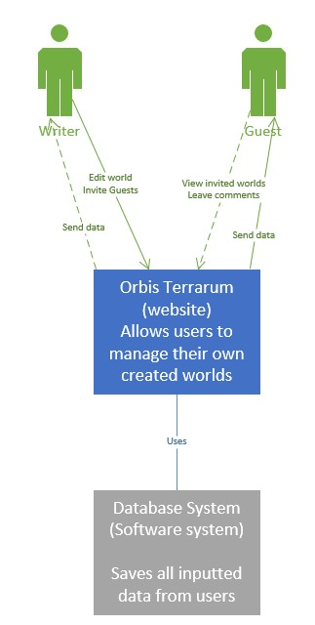

## Conceptual Diagram

# UI Design

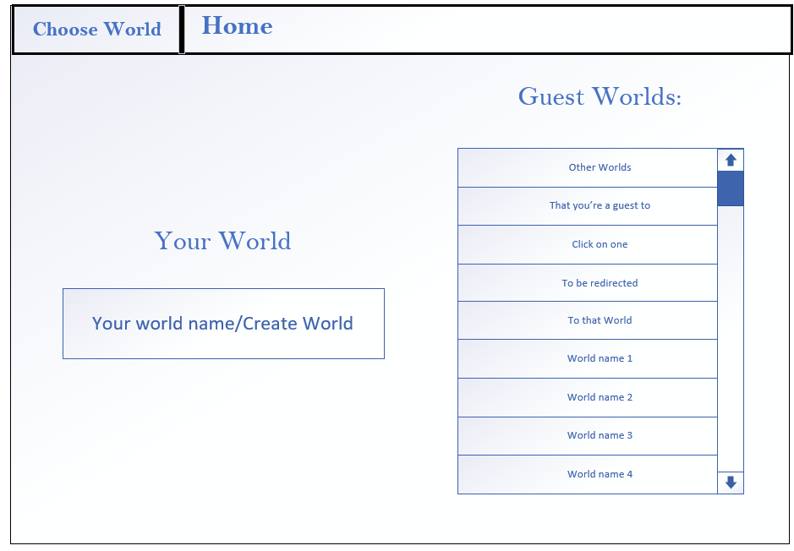

# Test Cases

| **Test Case** | **Use Case** | **Input** | **Expected Output** |
| --- | --- | --- | --- |
| TC-01 | UC-01 | Description: Website user logs in on dashboard.  User role: user. | The user logs in to the dashboard. |
| TC-02 | UC-01 | Description: Website user uses incorrect log in information.  User role: user. | The Website throws an exception that the login information is incorrect |
| TC-03 | UC-02 | Description: The user goes through the process of creating a world.  User role: Creator. | The user successfully creates a world in the database. |
| TC-04 | UC-02 | Description: The user tries to create a world but does not fill in all needed information. User role: Creator. | The software throws a warning that all information needs to be filled in. |
| TC-05 | UC-02 | Description: The user tries to create a world when they are at the cap. User role: Creator. | The software sends them back to the dashboard and gives a warning that the maximum cap on worlds is reached. |
| TC-06 | UC-03 | Description: The user clicks on any world they have access to view it. User role: User. | The software directs the user to the dashboard page of the world. |
| TC-07 | UC-03 | Description: The user tries to navigate to a world, but they do not have access to one yet. User role: User. | The software does not display any worlds for the user to navigate. |
| TC-08 | UC-04 | Description: The user goes to the edit page of a world and changes some of the information of the world/ User role: Creator. | The software updates the information stored in the database with the changed info the creator filled in. |
| TC-09 | UC-04 | Description: The user goes to the edit page of a world and edits some information; important fields are left empty or with incorrect information. User role: Creator. | The software throws a warning that information has been incorrectly edited. |
| TC- | UC- | Description: User role: |  |